**ANOVA**

| *ANOVA - Response.rt* | | | | | | | | | | | | | |
| --- | --- | --- | --- | --- | --- | --- | --- | --- | --- | --- | --- | --- | --- |
| Cases | | Sum of Squares | | df | | Mean Square | | F | | p | | ω² | |
| condition |  | 0.035 |  | 1 |  | 0.035 |  | 0.204 |  | 0.651 |  | 0.000 |  |
| Residuals |  | 141.816 |  | 838 |  | 0.169 |  |  |  |  |  |  |  |
|  | | | | | | | | | | | | | |
| *Note.*  Type III Sum of Squares | | | | | | | | | | | | | |

**Descriptives**

| *Descriptives - Response.rt* | | | | | | | | | | | |
| --- | --- | --- | --- | --- | --- | --- | --- | --- | --- | --- | --- |
| condition | | N | | Mean | | SD | | SE | | Coefficient of variation | |
| coloured |  | 280 |  | 1.056 |  | 0.401 |  | 0.024 |  | 0.380 |  |
| miscoloured |  | 560 |  | 1.070 |  | 0.416 |  | 0.018 |  | 0.389 |  |
|  | | | | | | | | | | | |

**Descriptives plots**

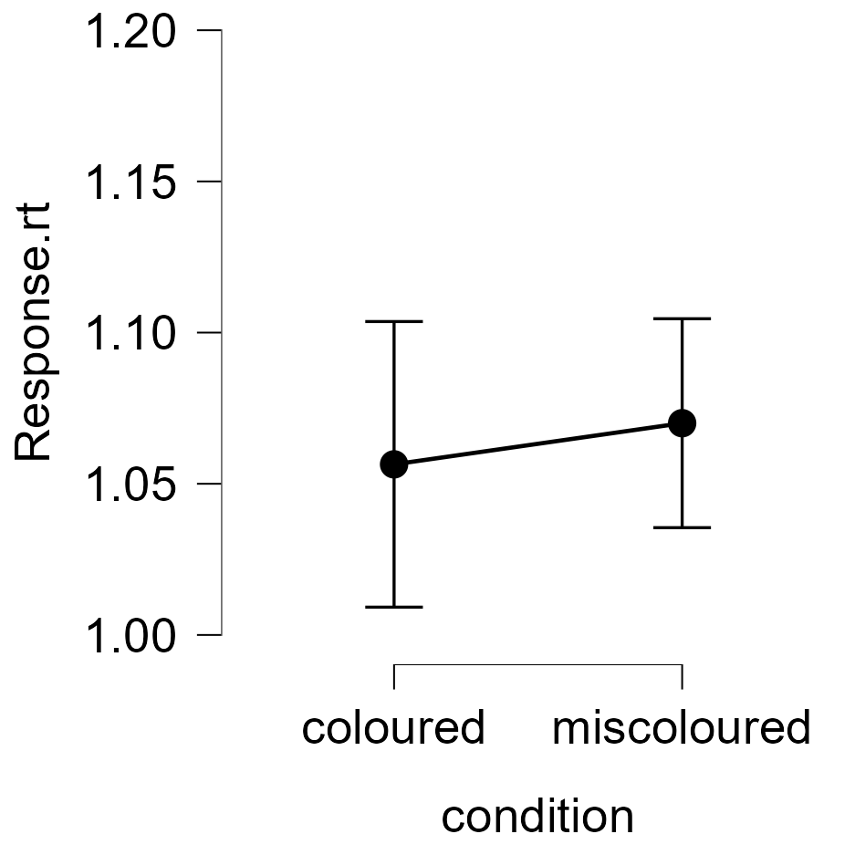

**Bar plots**

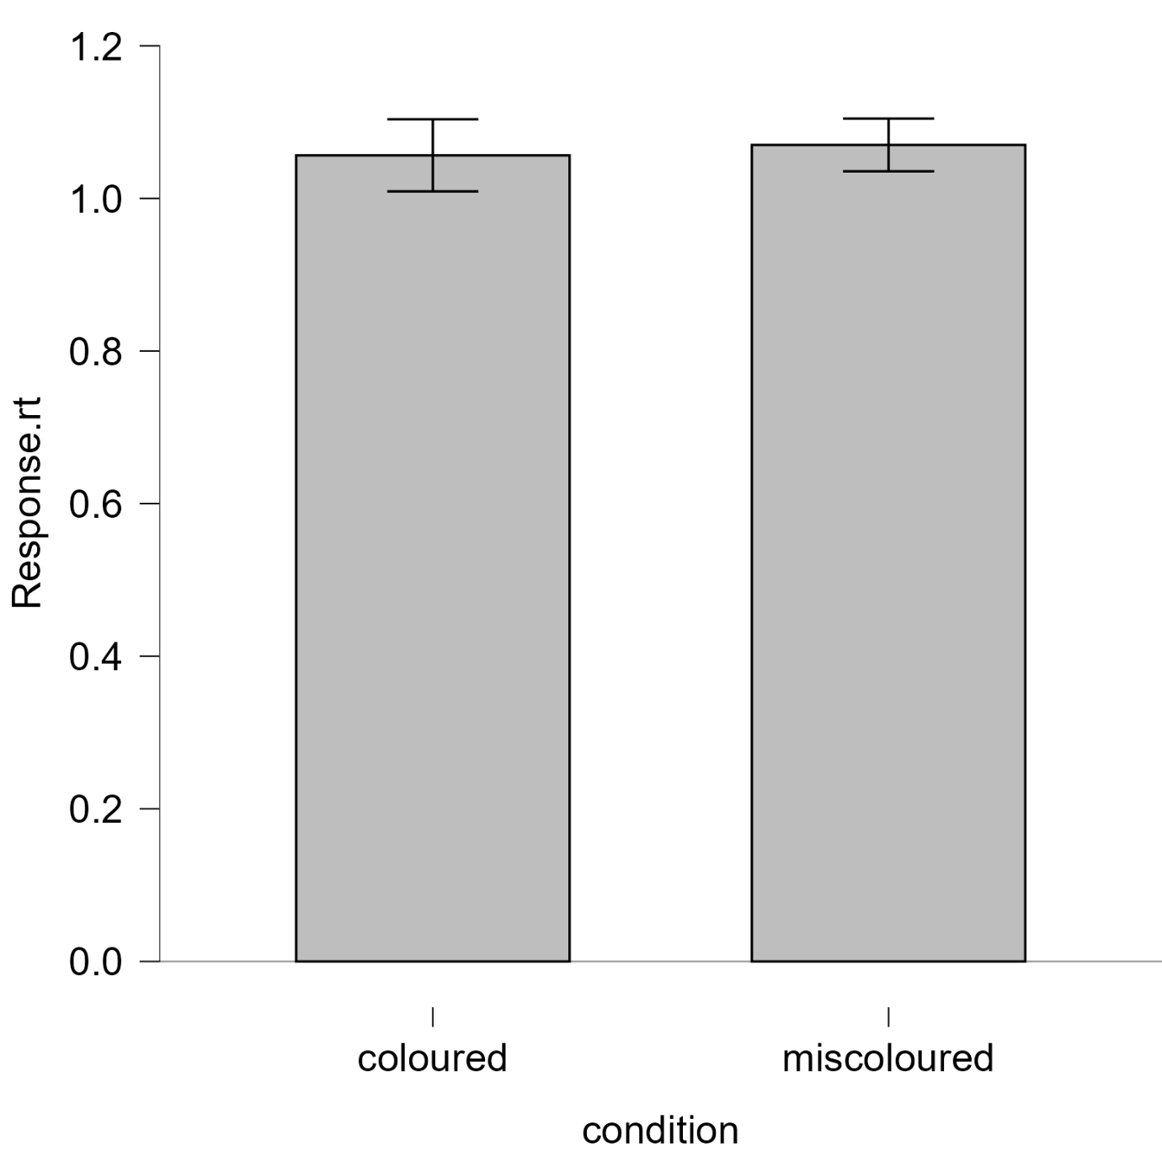

**Assumption Checks**

| *Test for Equality of Variances (Levene's)* | | | | | | | |
| --- | --- | --- | --- | --- | --- | --- | --- |
| F | | df1 | | df2 | | p | |
| 0.156 |  | 1.000 |  | 838.000 |  | 0.693 |  |
|  | | | | | | | |

CHI SQUARE TESTS FOR ACCURACY (Experimental condition)

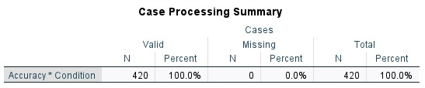

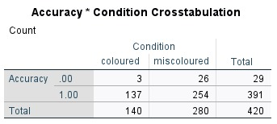

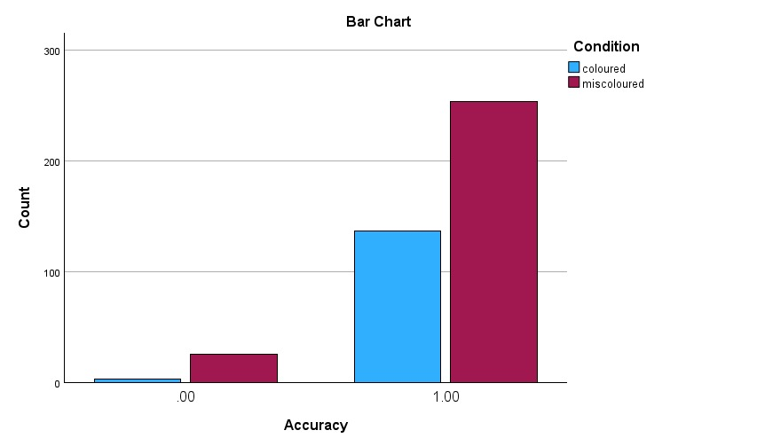

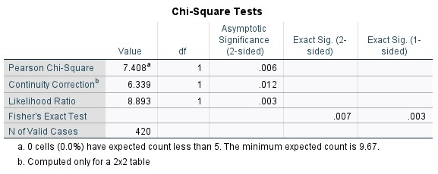

CHI SQUARE (Control group)

